Supplemental Fig.1
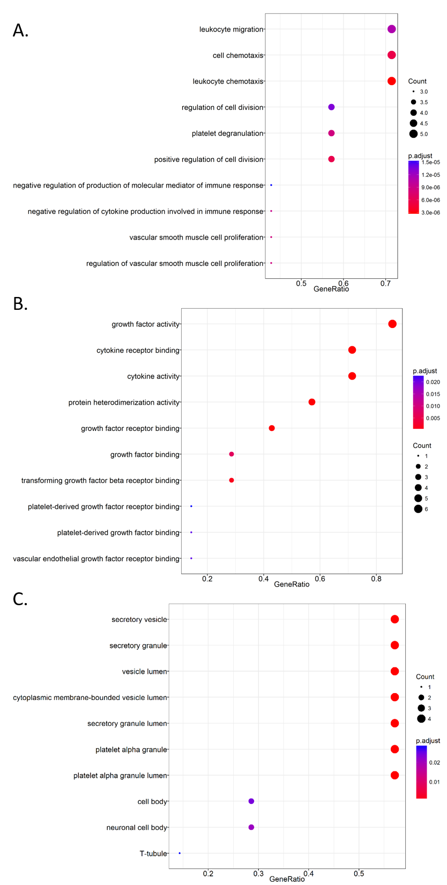
Fig. S1. The differentially expressed cytokines and chemokines affected by SLC7A5 in RA FLS were analyzed by GO terms. (A). biological process, (B). molecular function, (C). cellular component.
Supplemental material tables
Table S1. Primer
Gene symbol |  | Sequence (5'-3') | PCR product size (bp) | Annealing temperature (℃)
(GenBank accession number) |  | Sequence (5'-3') | PCR product size (bp) | Annealing temperature (℃)
Slc7a5 | F | CCGTGAACTGCTACAGCGT | 113 | 60
NM_003486.6 | R | CTTCCCGATCTGGACGAAGC | 113 | 60
Gapdh | F | GGAGCGAGATCCCTCCAAAAT | 197 | 60
NM_001256799 | R | GGCTGTTGTCATACTTCTCATGG | 197 | 60
Mmp3 | F | CTGGACTCCGACACTCTGGA | 79 | 60
NM_002422.4 | R | CAGGAAAGGTTCTGAAGTGACC | 79 | 60
Mmp13 | F | AATATCTGAACTGGGTCTTCCAAAA | 102 | 60
NM_002427.3 | R | CAGACCTGGTTTCCTGAGAACAG | 102 | 60

Table S2. Cytokine dot ELISA list
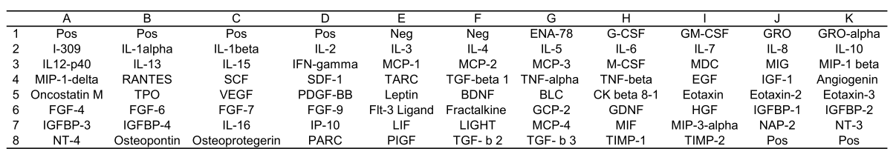

Table S3. Cytokine expression
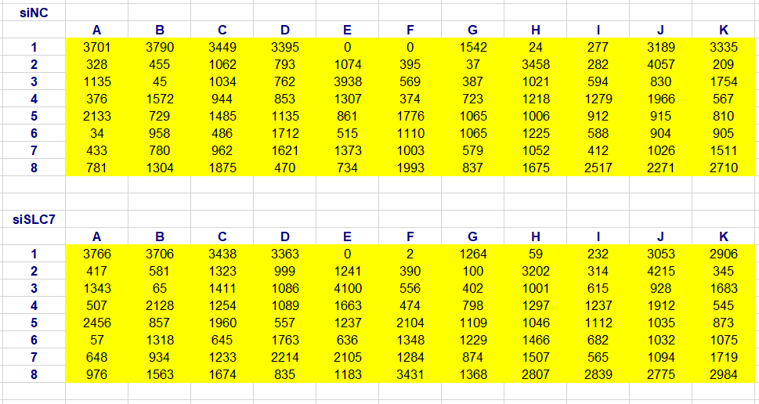

Table S4. KEGG pathway analysis
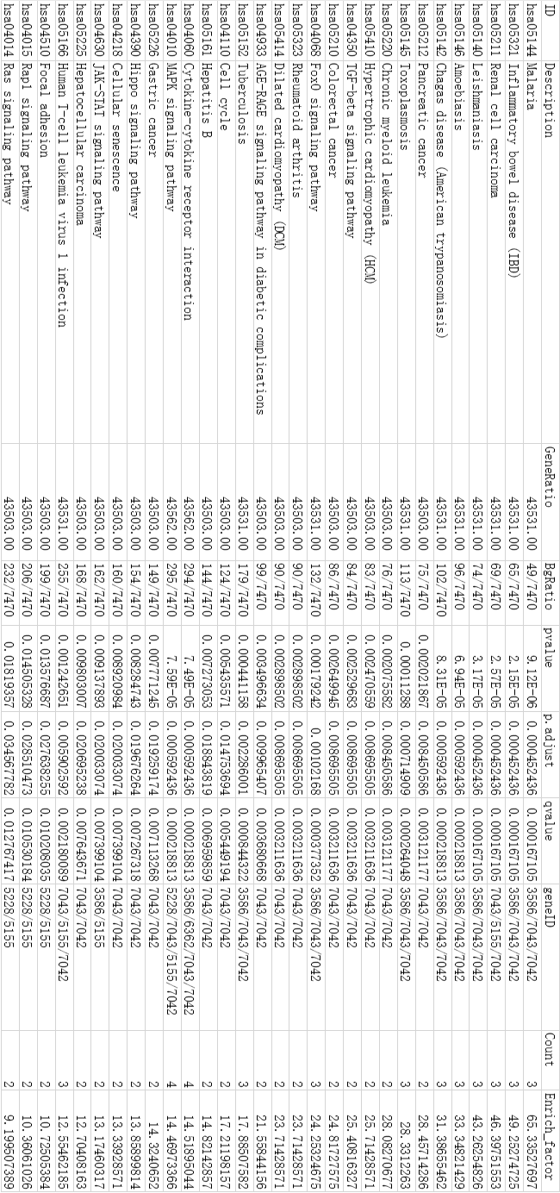

Table S5.Primary antibodies
Primary antibody | Dilution ratio | Company
rabbit anti-SLC7A5 | 1/200 | Boster, BA3479, China
rabbit anti-p-mTOR | 1/1000 | CST, #9862 kit, USA
rabbit anti-mTOR | 1/1000 | CST, #9862 kit, USA
rabbit anti-p-P70S6K | 1/1000 | CST, #9862 kit, USA
rabbit anti-P70S6K | 1/1000 | CST, #9862 kit, USA
rabbit anti-p-JNK1/2 | 1/2000 | CST, #4668, USA
rabbit anti-JNK1/2 | 1/1000 | CST, #9252, USA
rabbit anti-IκBα | 1/500 | Proteintech, 10268-1-AP, China
rabbit anti-MMP3 | 1/1000 | Abcam, ab53015, USA
rabbit anti-MMP13 | 1/1000 | Abcam, ab39012, USA
mouse anti-β-actin | 1/2000 | Earthox, E021020-03, USA

